BIIT PROJECT PROGRESS
MONITORING SYSTEM



By

GOHAR ALI (2018-ARID-0996)
RASHID ALI (2018-ARID-1102)
ATTIQUE AWAN (2018-ARID-1053)
SAYYAM NADEEM (2018-ARID-1073)
WALEED IQBAL (2018-ARID-1030)

Bachelor of Science in Computer Science
(BSCS)

Barani Institute of Information Technology
PMAS Arid Agriculture University Rawalpindi

Spring/Fall/Summer 2021
BIIT PROJECT PROGRESS
MONITORING SYSTEM



A report submitted in partial fulfillment of the
requirements for the degree of
Bachelor of Science in Computer Science

Submitted By
GOHAR ALI (2018-ARID-0996)
RASHID ALI (2018-ARID-1102)
ATTIQUE AWAN (2018-ARID-1053)
SAYYAM NADEEM (2018-ARID-1073)
WALEED IQBAL (2018-ARID-1030)
Supervised By
Mr. Umer farooq

Barani Institute of Information Technology
PMAS Arid Agriculture University Rawalpindi

Spring/Fall/Summer 2021

CERTIFICATE

It is certified that the contents and form of thesis entitled BIIT Project Progress Monitoring System submitted by Gohar Ali, Rashid Ali, Attique Awan, Sayyam Nadeem and Waleed Iqbal have been found satisfactory for the requirement of the degree.

SUPERVISORY COMMITTEE

PROJECT SUPERVISOR: _____________________
Mr. Umar Farooq

REPORT COORDINATER: _____________________
Mr. Qasim Shahzad

WRITEUP COMMITTEE HEAD: _____________________
Dr. Mohsin Raza

ACKNOWLEDGEMENT

We would prefer to specific our deepest appreciation to all those who provided us the possibility to complete this report. A special gratitude, We tend to offer to our final year project supervisor, Mr. Umer Farooq whose contribution in stimulating suggestions and encouragement, helped us to coordinate our project particularly in scripting this report.
Furthermore, we additionally prefer to acknowledge with abundant appreciation the crucial role of the Barani Institute of Information Technology’s administration, whose polite behavior and guidance help us to complete the task of our project report. We have to appreciate the guidance given by report coordinator, Mr. Qasim Shehzad, further the panels particularly in our project presentation that has improved our presentation skills thanks to their comment and advices.
May Allah bless all these people (Ameen)

ABSTRACT

Progress monitoring is an essential task of the Software Project Management (SPM), which is executed during the development process of software projects. In the market today, several tools are available for monitoring the progress of a project. However, most of these tools lack sufficient progress monitoring mechanisms, making them unattractive for many organizations. Moreover, some of the tools do not report and/or visualize useful information regarding the project status. To address these limitations, this study investigates some of the common tools used by Software Development Organizations (SDOs), which leverage on project management approaches and the concept of incremental technique. The SPM tools' pros and cons were identified through a literature survey. The key limitations were highlighted to show the gap in this area that led to the inception of this study. Resultantly, a BIIT Project Progress Monitoring System (BPPMS) was developed to overcome the limitations of the existing tools used in SPM. Subsequently, BPPMS was tested and evaluated by interviewing seven software practitioners. The initial results indicate that BPPMS is a useful and effective tool for software project monitoring task. Future work will focus on improving BPPMS based on the constructive suggestions and recommendations provided by the software practitioners.

Table of Contents

CERTIFICATE ii
ACKNOWLEDGEMENT iii
ABSTRACT iv
Table of Contents v
LIST OF FIGURES vii
Chapter 1 1
INTRODUCTION 1
1.1 Introductory Background 1
1.2 Problem Statement 2
1.3 Scope 3
1.4 Objectives 3
Chapter 2 4
PROJECT BACKGROUND 4
LITERATURE REVIEW 4
2.0 Introduction 4
2.1 Current State of affairs 4
2.2 Proposed system 4
2.3 Related systems 5
2.3.1 Progress Monitoring System for Students Final Year Project 5
2.3.2 Final Year Supervision Management System as a Tool for Monitoring Computer Science Projects 5
2.3.3 Online Student Supervision Management System (OSSMS) 6
2.3.4 ManageEngine Service DeskPlus 7
2.3.5 Lessons from the review of related applications 7
2.4 Related Literature 7
2.5 Conclusion 9
Chapter 3 10
CONCEPTUAL DESIGN 10
3.1 Requirement Specification 10
3.1.1 Functional Requirement: 10
3.1.2 Non-Functional Requirements 10
3.2 Requirement Modeling 11
3.2.1 Dataflow Diagram 11
3.3 Usecase Diagram 12
3.4 Database Design 13
3.4.1 Entity Relation Diagram 13
3.5 Logical Design 14
3.5.1 Conceptual Diagram 14
3.6 Project Mockups 15
3.6.1 Project Committee Mockups 16
3.6.2 Student Mockups 19
3.6.3 Supervisor Mockups 22

LIST OF FIGURES

Figure 1: Dataflow Diagram Level-0 11
Figure 2: Dataflow Diagram Level-1 11
Figure 3: Usecase Diagram 12
Figure 4: Entity Relation Diagram 13
Figure 5: Conceptual Diagram 14
Figure 6: Login Screen 15
Figure 7: Get Started 15
Figure 8: Students Selection 16
Figure 9: Committee Dashboard 16
Figure 10: Group Detail 16
Figure 11: Allocation 16
Figure 12: Group Tasks and Progress 17
Figure 13: Group Tasks 17
Figure 14: Assign Task 17
Figure 15: Task Detail 17
Figure 16: Group List 18
Figure 17: Mark Attendance 18
Figure 18: Meeting Detail 18
Figure 19: Meeting List 18
Figure 20: Attendance Detail 19
Figure 21: Individual's Tasks 19
Figure 22: Student Dashboard 20
Figure 23: Meeting List 20
Figure 24: FYP-2 Tasks 20
Figure 25: FYP-1 Tasks 20
Figure 26: Task Detail 21
Figure 27: Task List 21
Figure 28: Supervisor Dashboard 22
Figure 29: Group Detail 22
Figure 30: Meeting Detail 22
Figure 31: Meeting List 22
Figure 32: Task Detail 23
Figure 33: Group Tasks 23
Figure 34: Assign Task 23

Chapter 1

INTRODUCTION

1.1 Introductory Background

Project monitoring is a significant part of project management. All project activities should be carefully monitored while the project is being accomplished. This helps project manager to keep informed of work progress, and apply timely correctives. It is essential that project monitoring is simple and not time-consuming. Project monitoring software may really help to simplify this process. First, it is necessary to define project goals and plan the activities (Swapna, 2001). Nowadays, project monitoring will implemented and will use for final year project's student. The purpose of this implemented because to achieve the goal of project undergraduate's subject in university. This way, it helps to track student if they are have problem to finish their project. The step for approach student totally different for each supervisor. So, the best way to keep track student is through web based system. Before this, data and information for FYP is recorded as manually. Staffs need to record all data and information and keep all information in files. Recorded as manually will make the data and information lost. This is not consistent in order to find old record or data. It may cause waste of time when want to search any information.
Project monitoring is a significant part of project management. All project activities should be carefully monitored while the project is being accomplished. This helps project manager to keep informed of work progress, and apply timely correctives. It is essential that project monitoring is simple and not time-consuming. Project monitoring software may really help to simplify this process. First, it is necessary to define project goals and plan the activities (Swapna, 2001). Nowadays, project monitoring will implemented and will use for final year project's student. The purpose of this implemented because to achieve the goal of project undergraduate's subject in university. This way, it helps to track student if they are have problem to finish their project. The step for approach student totally different for each supervisor. So, the best way to keep track student is through web based system. Before this, data and information for FYP is recorded as manually. Staffs need to record all data and information and keep all information in files. Recorded as manually will make the data and information lost. This is not consistent in order to find old record or data. It may cause waste of time when want to search any information.
Therefore, the Progress Monitoring system for Student FYP allows its student to easily update project problems as they arise. Those update project problem, actually they are will get the feedback from supervisor. So, Supervisor will evaluate the progress and assign marks to student based on rubric. This system also can helps student streamline the project management process, helping to keep student on track and providing user with reports and real-time data so that their project success is assured.

1.2 Problem Statement

Each 7th semester student has been assigned a project which she/he has to work on it and submit it till the end of the degree. During the year, the student has also to submit various products that show the progress in his/her workings. The report each student has to submit are two (Research Report and Full Report). What the instructor (supervisor) has to do is to assess these products by completing special assessment forms regarding each product.
Based on observation from Andrew Hadiyonto, student has lack experience and insight. They often fail to estimate the time required to complete their task (Andrew Hadiyonto, ISATE 2011). They also failed to understand the whole process in completing the task. They are unable to determine accurately the current status of their project. Besides that, student may not have time to meet their supervisor. So that, many of them are often behind schedule without realizing it and can’t achieve the goal of FYP.
Normally, during supervision phase, students have to organize meeting with their supervisor to show their weekly progress on the project. Log book is compulsory to record all meeting between student and supervisor. Thus, it is difficult to manage students. All students will miss communication in order to achieve the good product. It is not easy to keep student connected with supervisor. One of the supervisor’s tasks in final year project is to track each student’s progress. One of the reason students fail to meet their supervisor because they are busy with their schedule and their time are limited. In addition, supervisor has one or more students to manage and hard to supervisor divided time to meet students. As a result, they cannot do corrections on their works to be submitted and will get lower marks for their project. So with this system, it will help users as it makes the software project smoother and easier.

1.3 Scope

BIIT project progress monitoring app help its users to monitor complete progress of student’s project. It will help in tracking the evaluation of their assigned tasks. It will also help in monitoring ongoing project activities. Supervisor can assign tasks and schedule meetings to their related project students and mark their attendance. Project committee can assign projects and supervisors to the students. They can also assign tasks and schedule meetings to their related project. Student can see their progress, tasks, and comments on his tasks. Supervisor and Project Committee can evaluate students according to their progress.

1.4 Objectives

The main objective was to automate the process of project monitoring as a way of creating proper accountability in relation to the project resource management hence minimizing issues like Communication gaps with supervisor and project committee.

This project embarks the following objectives:
1. To complete the final year project using systematic approach.
2. Completion with full repository and complete requirement following the timeline.
3. Evaluate the progress and assign marks based on rubric.

Chapter 2

PROJECT BACKGROUND

LITERATURE REVIEW

Introduction
This chapter gives a summary of the literature that has been researched by other scholars. In the area of global competition, organizations all over the world are competing through the use of the most comprehensive and advanced technological features., helps the researcher develop a thorough understanding and insight into previous works and trends that have been recorded pertaining to the research problem. The sources of this secondary data were mainly obtained from existing published books, policy documents, the internet, journals, newspapers, and past research it involves the strengths and limitations of the current system, related work, the conclusion and finally the proposed system.

2.1 Current State of affairs

Currently staff at Jomayi monitor the projects by physically moving to the site premises. There are folder files at the reception containing reports for different projects where staffs and customers checkout details about a given project. Staff or clients who want individual project reports check with the estate administration assistant in charge of their projects for the hard copy individual reports. Site managers are also given all individual reports for the projects worked upon. All this procedure of project monitoring progress consumes time.

2.2 Proposed system

The proposed project monitoring system is online based where by the users such as the customers, site engineers and site managers have access to the system on logging in and do different activities related to the privileges assigned to them. This system scrapped off the manual file based system, the new system supports automation and produces high quality in accuracy and data presentation, storage plus analysis which is more advantageous.

2.3 Related systems

2.3.1 Progress Monitoring System for Students Final Year Project

The Progress Monitoring System for Student Final Year Project (PSM) is computer software which helps student contacts of University Malaysia Pahang (UMP) under Faculty System Computer and Software Engineering (FSKKP) gain better control of their project planning and implementation through keeping student connected with supervisor.
Strengths of the system
- The supervisor interacts with his students for continently i.e. any time anywhere, there is no need for the students to move and physically see the supervisor.
- Provide mail portal services for someone who is not familiar with this project monitoring system
Weaknesses of the application
Some pages include too much information and there are little guidelines. There are too many options to choose, and the customers may easily get confused.

2.3.2 Final Year Supervision Management System as a Tool for Monitoring Computer Science Projects

This software used by Computer Science department of Universiti Kebangsaan Malaysia. Tjis software is meant to improve project monitoring and supervision. The software has several versions such as three modules, namely user profile, project monitoring (of software development and report writing) and appointment setting.
Strength
- The software has an appointment setting portal that helps the student to make appointment with their supervisors.
- There is also provision for submitting the assignments to the respective supervisors.
Weaknesses
- The software is limited to only Mach tosh systems and Linux

2.3.3 Online Student Supervision Management System (OSSMS)

Web-based Online Student Supervision Management System is an important means of achieving this goal. In comparison to the conventional use of pen and paper or the use of Email based on the old System, web Online Student Supervision Management System will significantly shorten the time taken by students to complete their projects or dissertations by enabling Online Student Supervision Management System without the restrictions of time and location. With OSSM, students can check with the system the availability of supervisors without meeting them. The Online Student Supervision Management System (OSSMS) is developed using Active Server Pages technology and the development tools used include Visual Studio 2008 (which includes a local web server) and Visual Basic scripting language. The backend database is supported by SQL Server 2008 Database, which is built into the Microsoft Visual Web Developer 2008 Express.
Strength
- The system enables accurate registration of students.
- The system facilitates authentication, so as to ensure only authorized users gain access to services such as registration, information retrieval and updating.
- The system provides basic functions and features such as validation, consistency and user friendliness.
- The system includes provide administrative features for the administrator (office staff) to maintain the database.
- The system allows for future enhancement of the system to improve its effectiveness
Weakness
- The system limits the amount of work to be uploaded to 2.5 MB.

2.3.4 ManageEngine Service DeskPlus
This is a web-based help desk and asset management software. If offers an integrated package with incident management (Trouble Ticketing) Assets Tracking, purchasing, contract management, self-service portal and knowledge based at an affordable price point. Service desk plus provides all that one needs to have a full-fledged IT Help Desk and productive Help Desk staff. This software is available in several versions.
Strength
- The software offers full time support to its users with an online helpline
Weakness
- The system is mainly meant for IT related monitoring projects such as ticketing

2.3.5 Lessons from the review of related applications

From the weaknesses of the reviewed systems, the system I designed addressed the following:
The system contained only key information to avoid confusing the users.
The menus were made big enough to allow users easily see them.
The designed was user friendly and users will not have difficulties in interacting with it.

2.4 Related Literature
Project monitoring is a significant part of project management. All project activities should be carefully monitored while the project is being accomplished. This helps project manager to keep informed of work progress, and apply timely correctives. It is essential that project monitoring is simple and not time-consuming. Project monitoring software may really help to simplify this process. First, it is necessary to define project goals and plan the activities (Swapna, 2001).
Theory of Constraints (TOC) Introduced by Dr. Eliyahu M. Goldratt (1984) in his Novel "The Goal". TOC is an overall management philosophy that is geared to help organizations continually achieve their goal. The title comes from the view that any manageable system is limited in achieving more of its goal by a small number of constraints, and there is always, at least, one constraint. The TOC process seeks to identify the constraint and restructure the rest of the organization around it by using Five Focusing Steps. The methods and algorithms from TOC went on to form the basis of Critical Chain Project Management.
Scrum Named as a Project Management Style (1986). Scrum is an agile software development model based on multiple small teams working in an intensive and interdependent manner. In their paper, 'The New Product Development Game' (Harvard Business Review, 1986) Takeuchi and Nonaka named Scrum as a project management style. Later they elaborated on it in, 'The Knowledge Creating Company' (Oxford University Press, 1995). Although Scrum is intended for management of software development projects, it can be used to run software maintenance teams, or as a general project and programmer manage. https://www.projectsmart.co.uk/brief-history-of-project-management.php
Among the first good examples of project management include the building and completion of the Great Pyramid of Giza in 2570 BC. Until now, even the top archaeologists are still arguing how the Egyptians were able to achieve this project. According to ancient records, managers were assigned for each of the Great Pyramid’s four faces who were responsible for the coordination and completion of the task. In that sense, there was some form of planning, implementation, and control involved in finishing this project.
The building of the Great Wall of China in 208 BC can also be argued what is considered among the best examples of project management. Since the rule of the Qin Dynasty, the Great Wall construction had been a very daunting project. Based on historical records, the dynasty’s labor force was composed of groups: soldiers, common people, and criminals. The emperor ordered millions of his people to complete this project.

2.5 Conclusion
This project’s aim was to develop Project progress Monitoring system for the Jomayi. It was utilized by clients and supervisors. The main benefit of this system is its potential to provide more convenience and greater accessibility for the monitoring of projects, and to allow easier and faster process made information retrieval easier, faster as compared to the current manual system, through the administration features provided.

Chapter 3

CONCEPTUAL DESIGN

3.1 Requirement Specification

3.1.1 Functional Requirement:

- Login
- Supervisor
  - Assign tasks (weekly base)
  - Mark student attendance
  - View, grade & comment on student’s progress
- Director/Project Committee
  - View supervisor’s comments and student’s progress
  - Monitor student attendance
  - Comment & evaluate Student’s progress
- Student
  - Monitor attendance
  - Chat with supervisor
  - Overview his progress (grades and comments)

3.1.2 Non-Functional Requirements

These are behavioral characteristics of the system and these include:
- The system has a login page for security
- It works day and night 24/7.
- It allows storage of building materials and customer details.
- It has an attractive user interface.

3.2 Requirement Modeling

3.2.1 Dataflow Diagram
Data flow diagram shows the flow of your data in project or system and how to control your process of database. 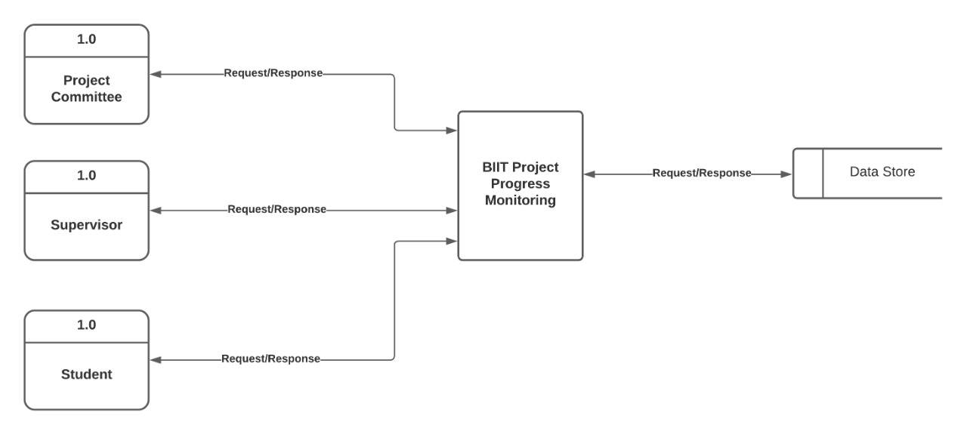
Figure 1: Dataflow Diagram Level-0

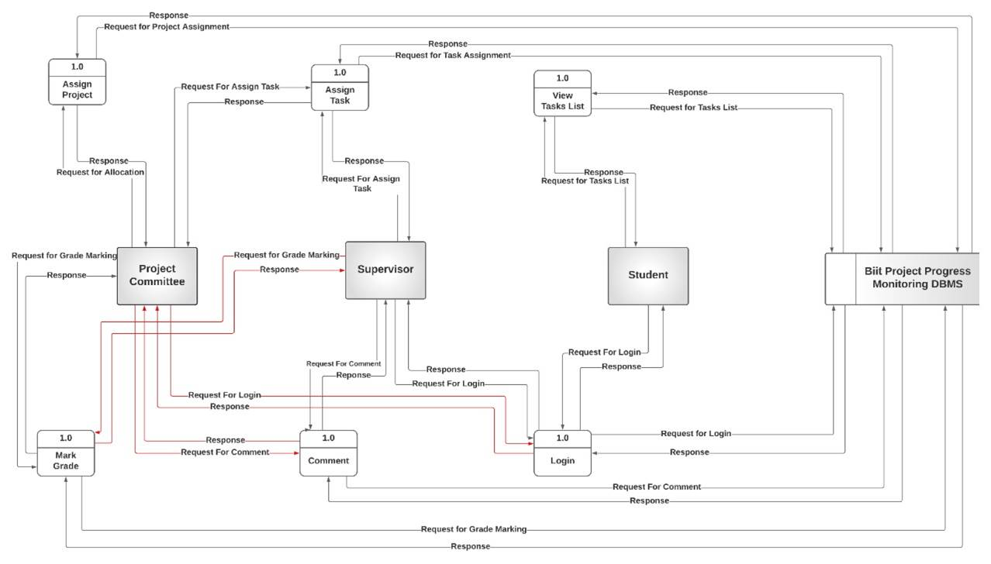
Figure 2: Dataflow Diagram Level-1

3.3 Usecase Diagram
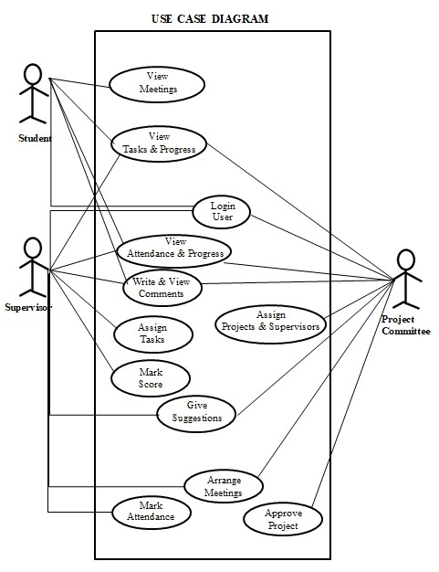
Figure 3: Usecase Diagram

3.4 Database Design
In this section I would discuss about the database model using entity relation diagram. In this diagram shows the entities or tables of database with their relations and also display the attributes of all entities.

3.4.1 Entity Relation Diagram

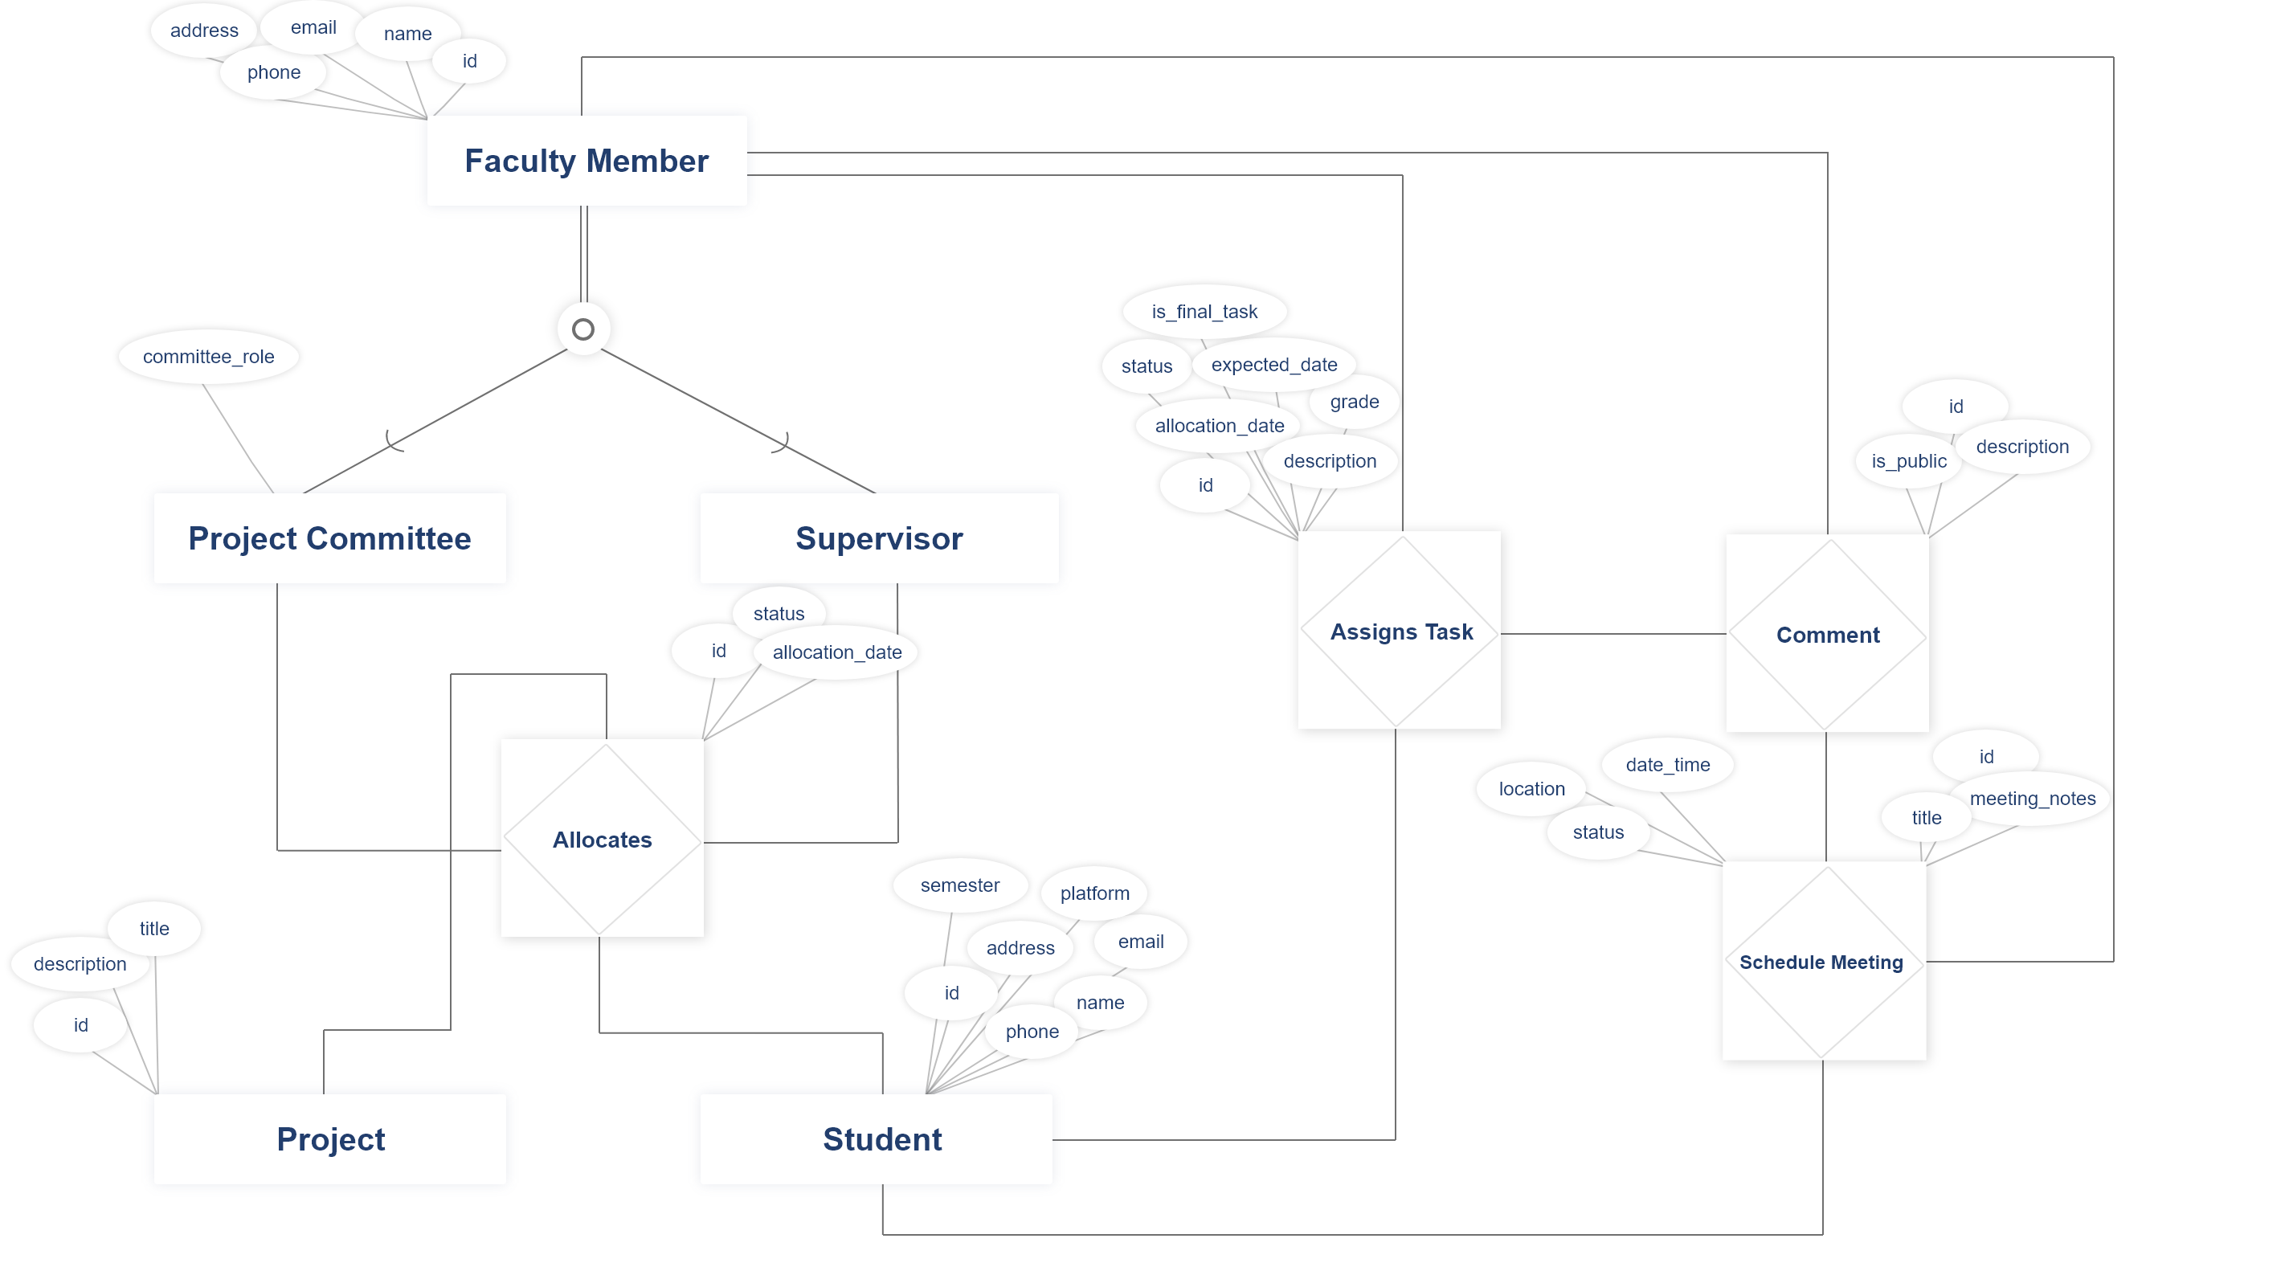
Figure 4: Entity Relation Diagram

3.5 Logical Design

3.5.1 Conceptual Diagram

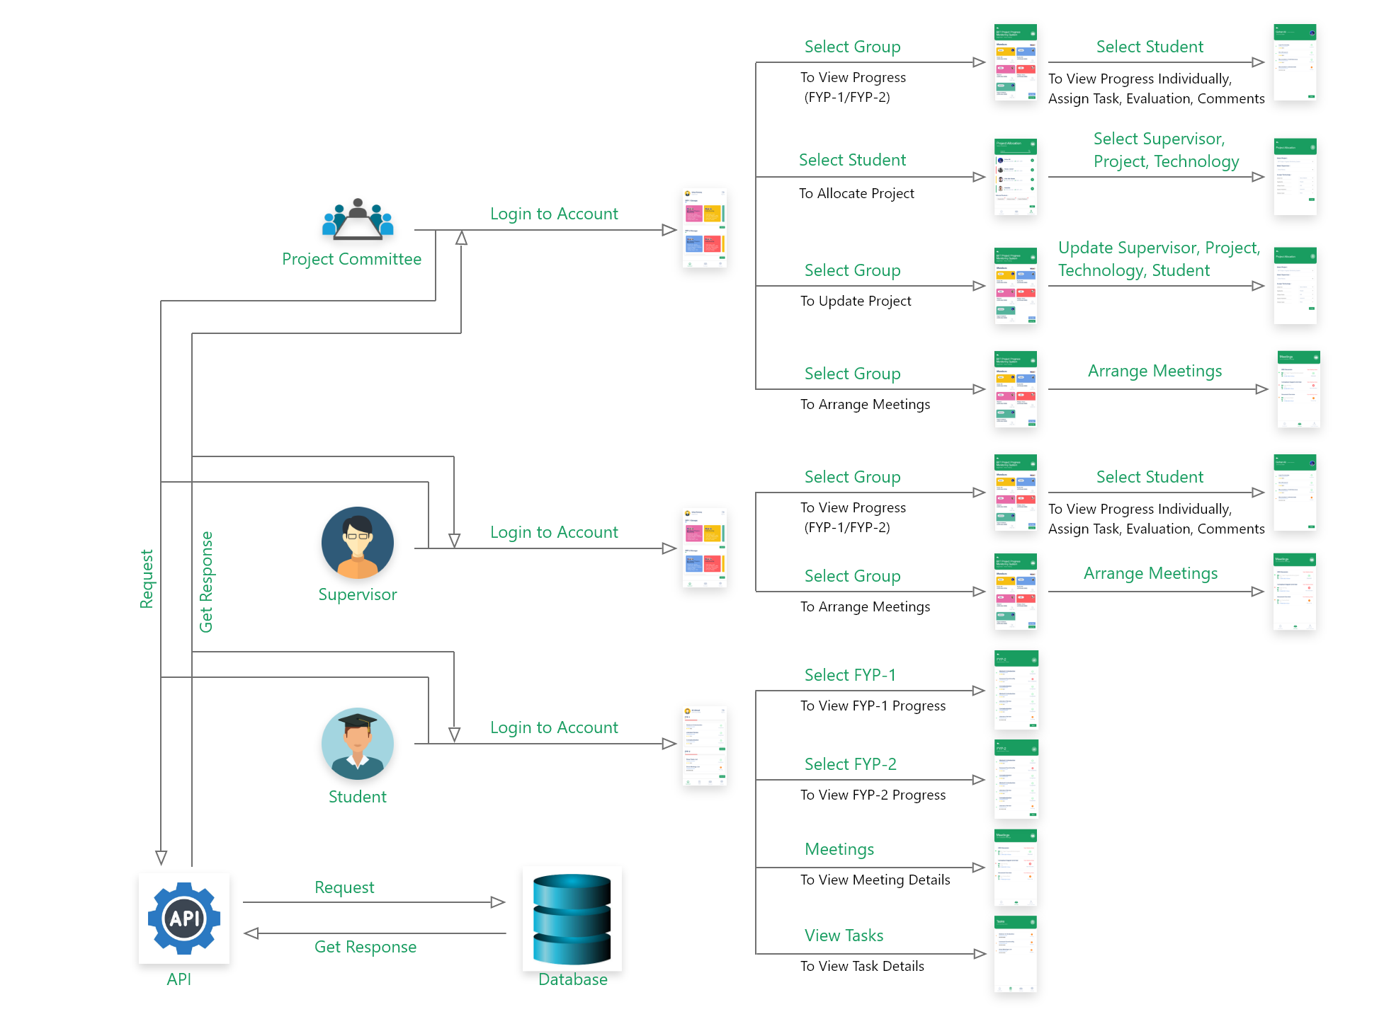
Figure 5: Conceptual Diagram

3.6 Project Mockups

In this Section I would describe about Project UI / UX (Mockups).

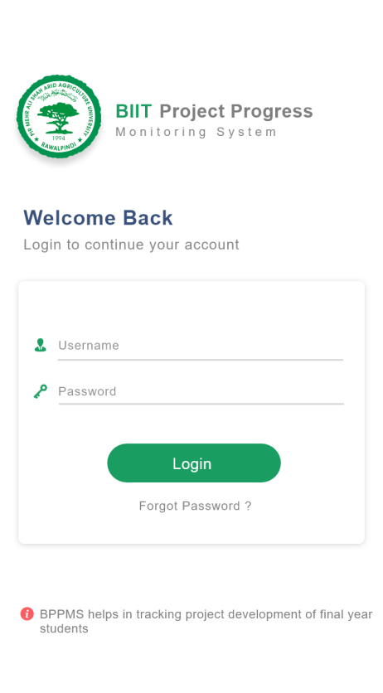
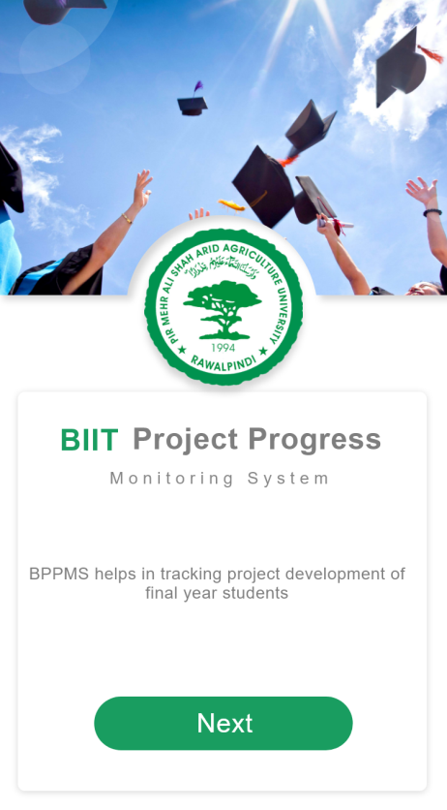
Figure 6: Login Screen
Figure 7: Get Started

3.6.1 Project Committee Mockups

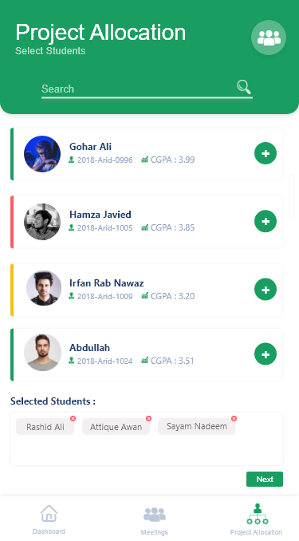
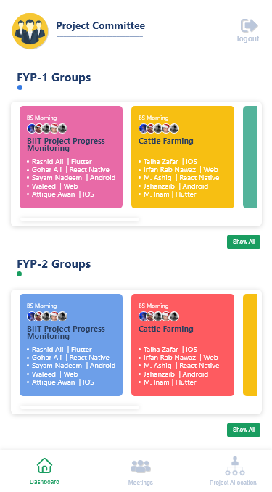
Figure 8: Students Selection
Figure 9: Committee Dashboard

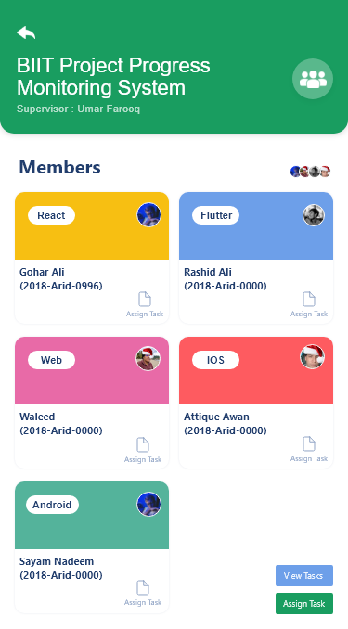
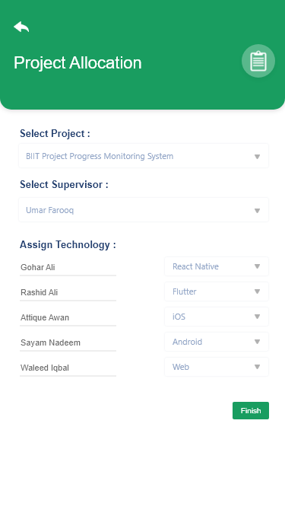

Figure 10: Group Detail
Figure 11: Allocation

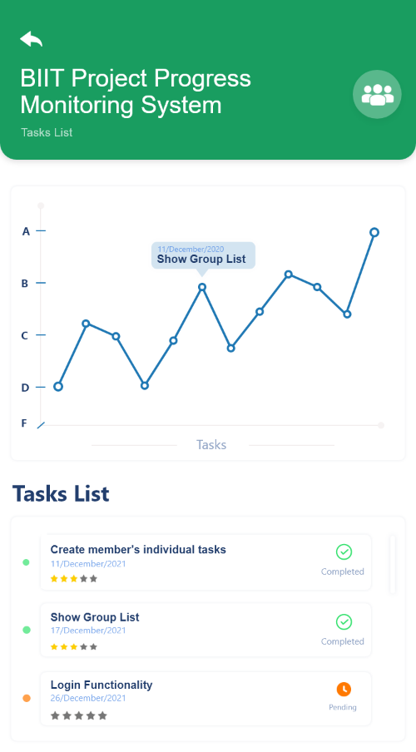
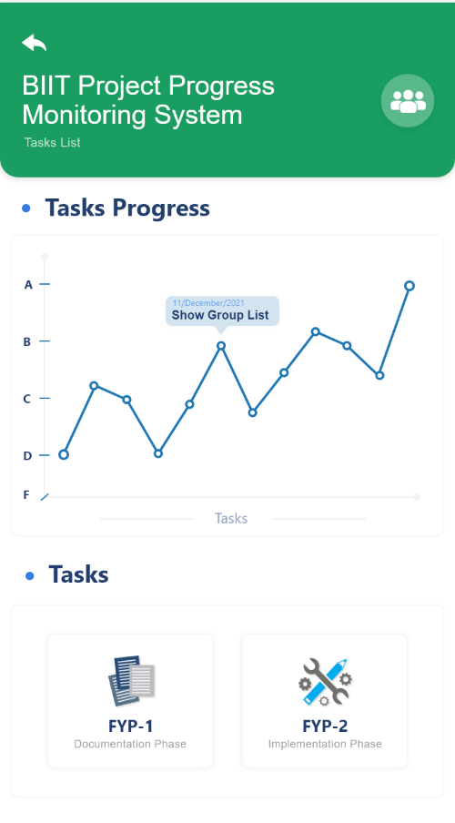
Figure 12: Group Tasks and Progress
Figure 13: Group Tasks
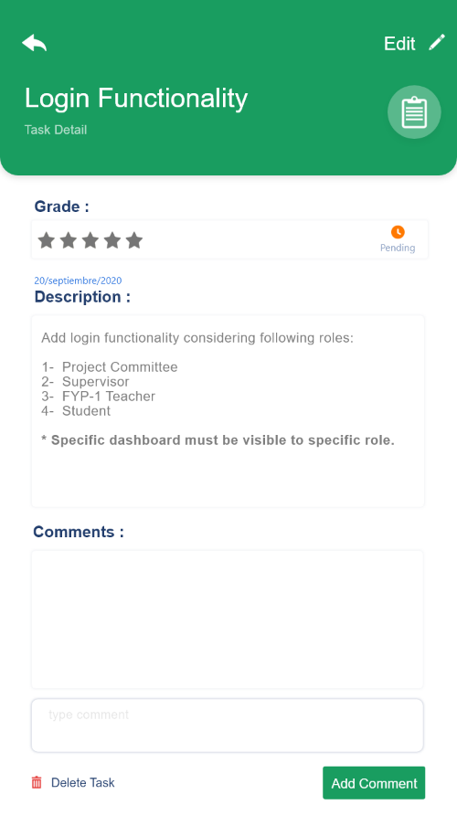
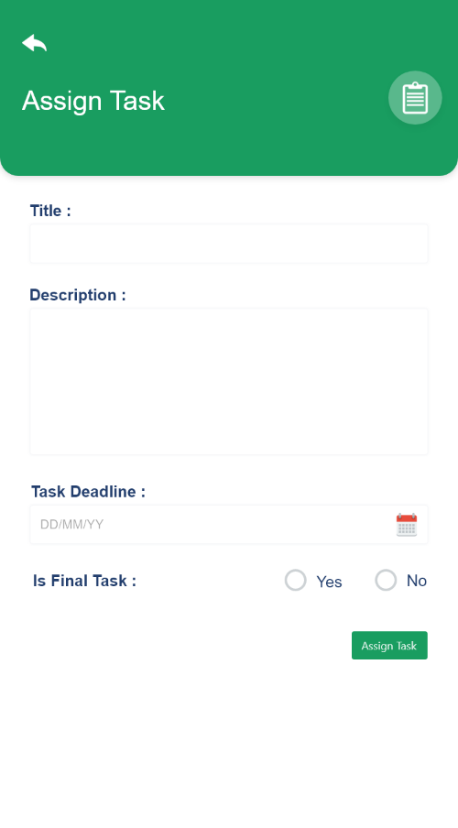
Figure 14: Assign Task
Figure 15: Task Detail
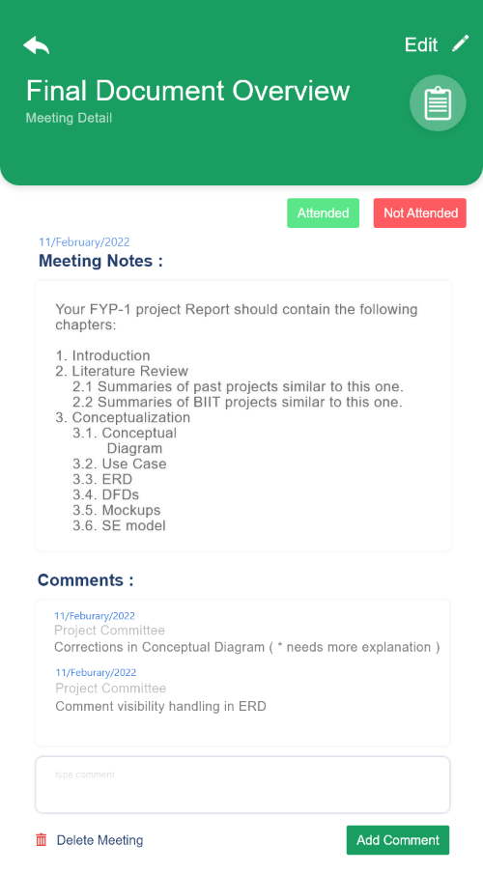
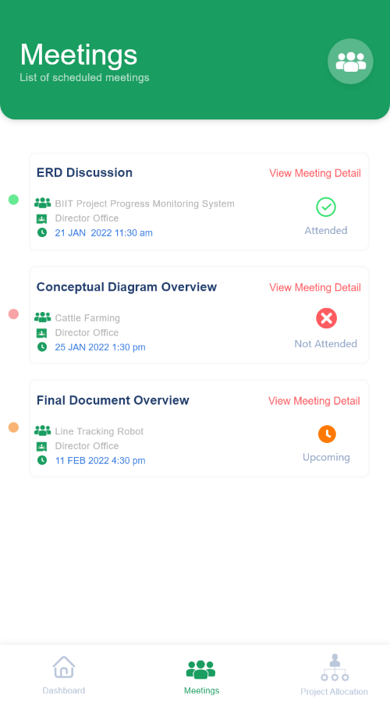

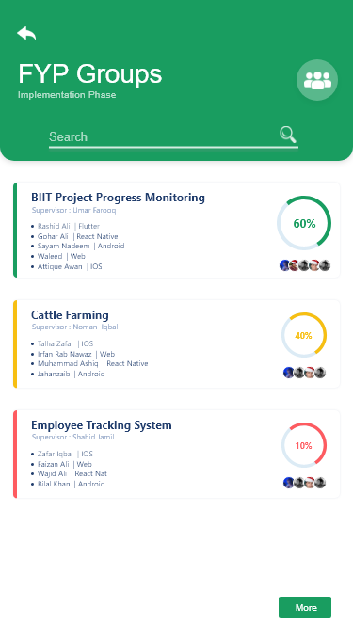
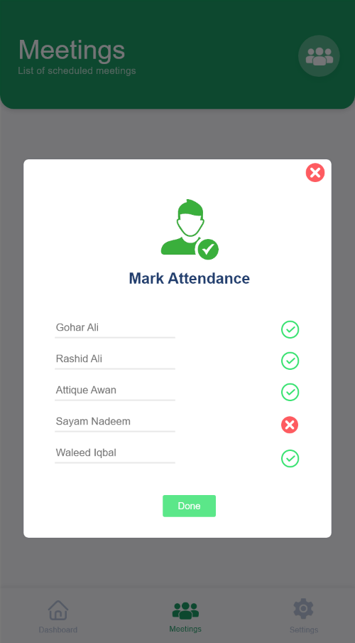
Figure 16: Group List
Figure 17: Mark Attendance
Figure 18: Meeting Detail
Figure 19: Meeting List

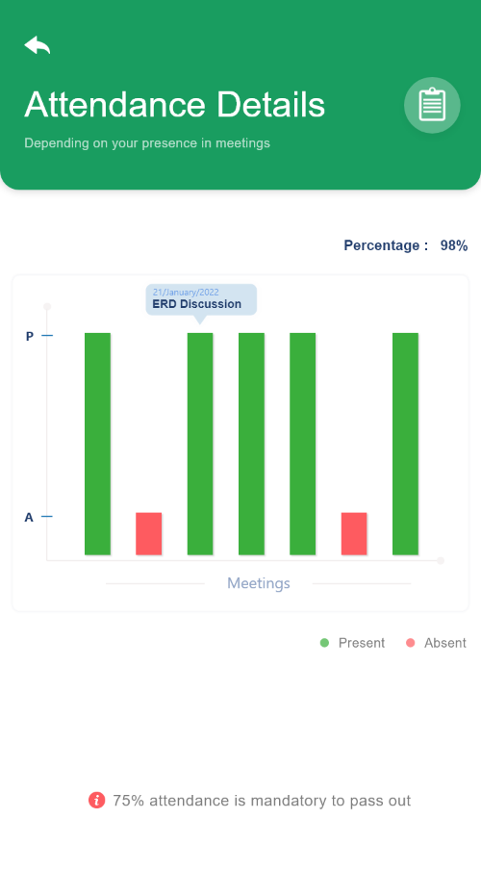
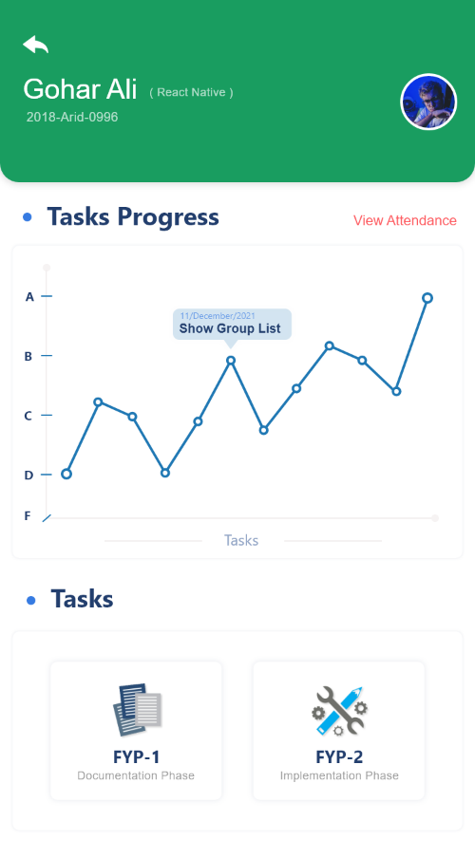
3.6.2 Student Mockups
Figure 20: Attendance Detail
Figure 21: Individual's Tasks

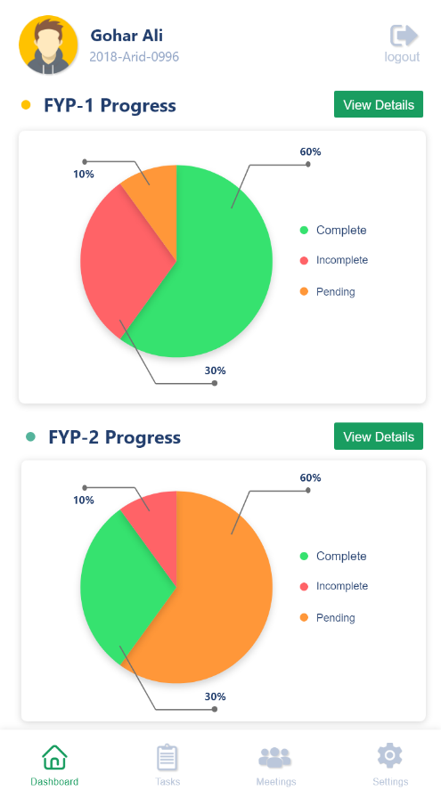
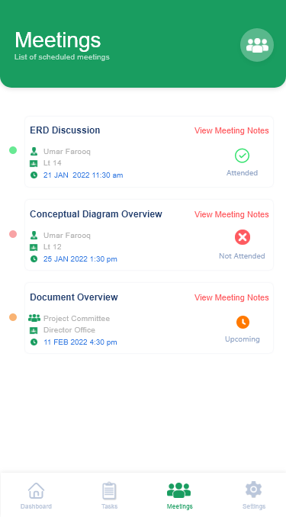
Figure 22: Student Dashboard
Figure 23: Meeting List

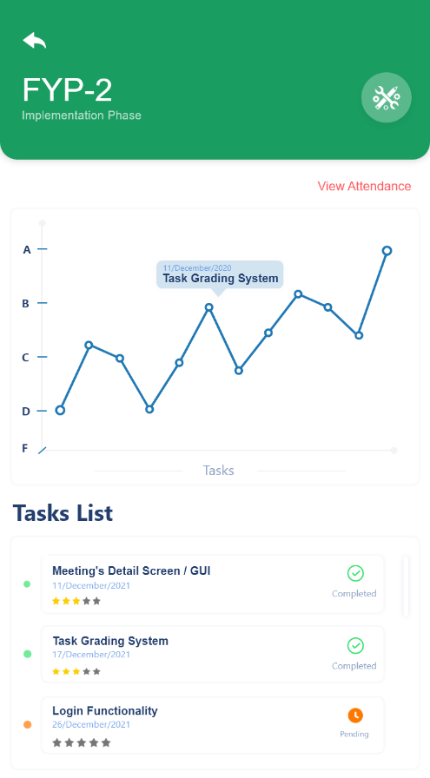
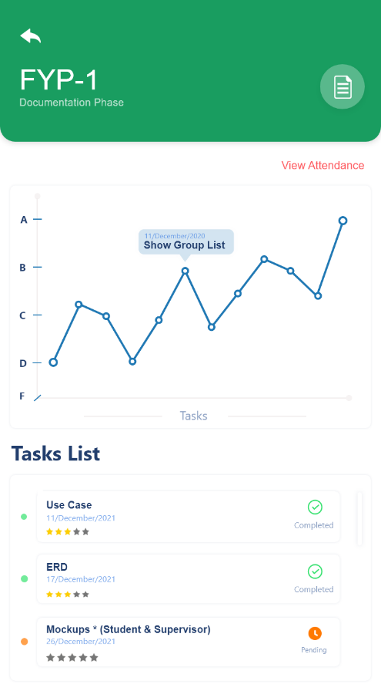
Figure 24: FYP-2 Tasks
Figure 25: FYP-1 Tasks

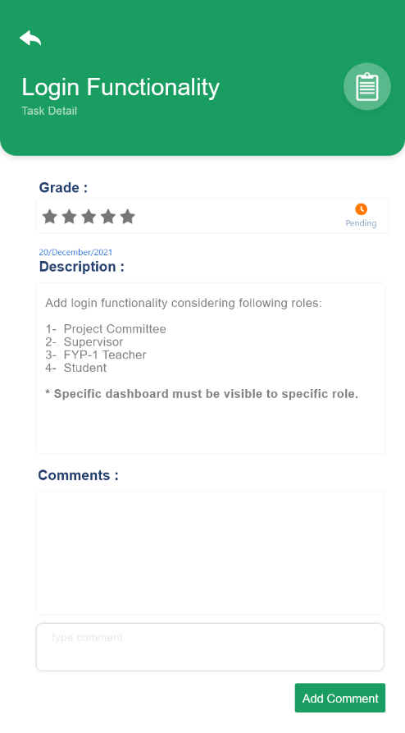
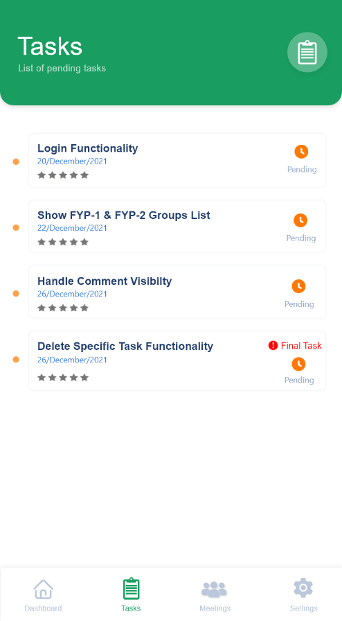
Figure 26: Task Detail
Figure 27: Task List

3.6.3 Supervisor Mockups

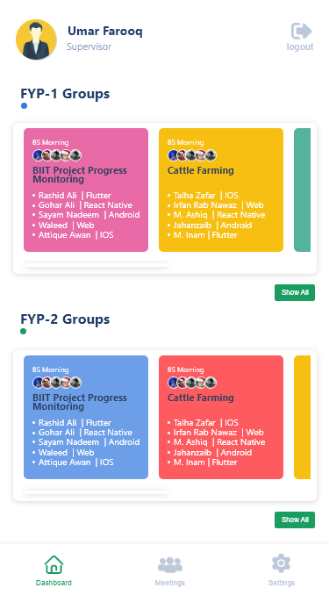
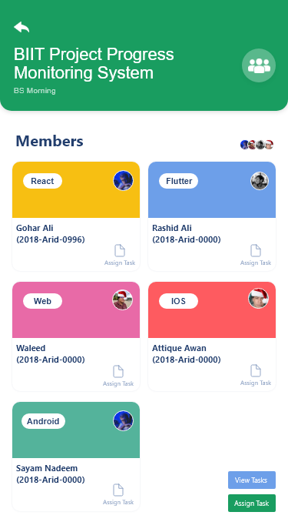
Figure 28: Supervisor Dashboard
Figure 29: Group Detail

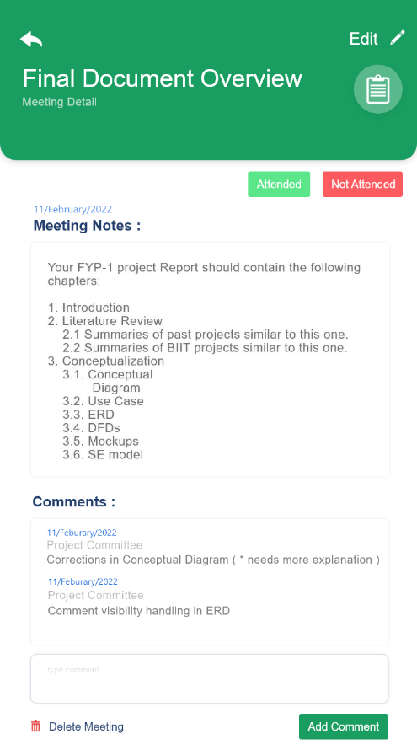
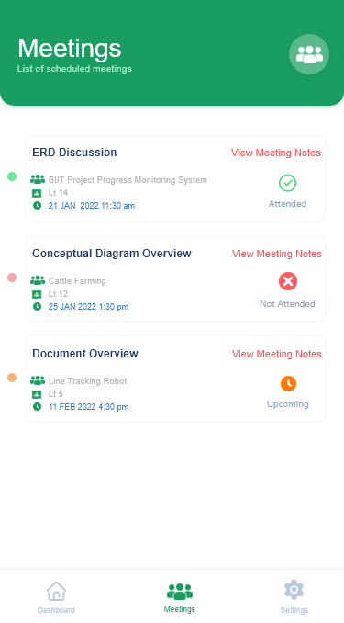
Figure 30: Meeting Detail
Figure 31: Meeting List

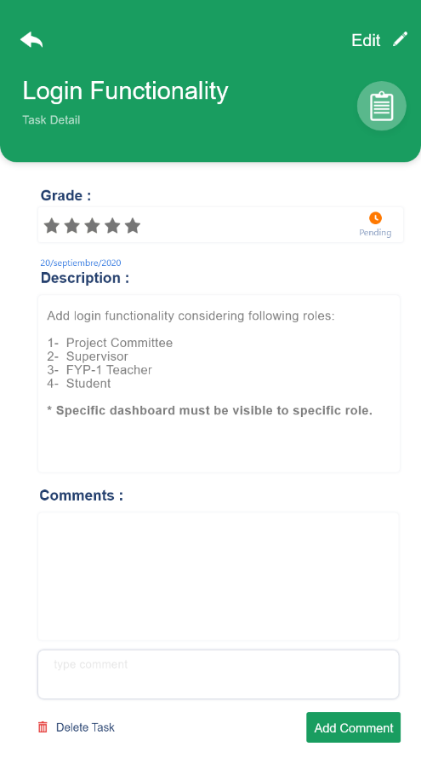
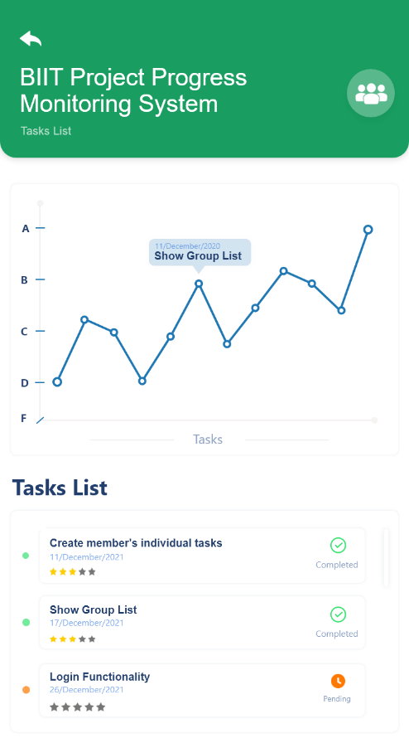
Figure 32: Task Detail
Figure 33: Group Tasks

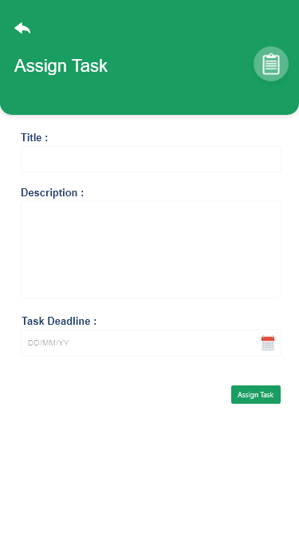
Figure 34: Assign Task

